
Grouping Books and Menubar - a How to
Written by Roger Pfister http://RogerPf.com/aaBridge
Creating a lin file is covered elsewhere in the aaBridge documentation in documents such as
Enter (Type) Hands into aaBridge.doc
and the internal self administered course
102__aaBridge_and_Lin_Files
This document is all about the feature added in aaBridge v 6.0 This feature allows you to group a collection of “Books” into a single file which …
… when you use Drag and Drop will create its own menubar entry.
The file
Grand Slams.linzip

is supplied as an example in the aaBridge document collection it goes with THIS document.
Drag and drop the file above onto an open aaBridge window and you should see …
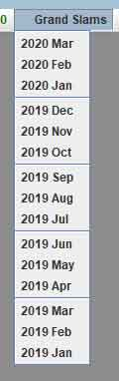
the new text in red Grand Slams appear in the menubar.
When that new menubar option is clicked on you should see its menu.

Where is it most useful
You can use this feature when you have a large number of lin files that you want to show to other people. For example you may have a collection of deals that you or someone else has played over many years.
While you COULD save such a collection in in a single zip file being able to add structure to the lin file collection has benefits.

How to make a “Grouped Book” - the Books-E name
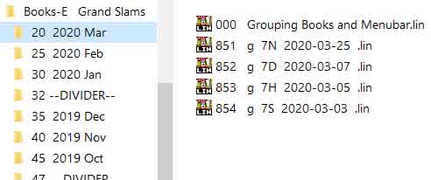
Take the existing example and unzip it using whatever tool comes with your operating system. On Windows it can look something like…
Here you can see that the grouped book
Grand Slams.linzip
Contains a top
Books-E Grand Slams
under that is a list of folders each with a Year a Month e.g. 2020 March that match the entries in the menu shown earlier.
Each of the “month folders” contain the lin files that you see if you select that entry while in aaBridge.
Notice that the folder names always start with a REQURED two digit ordering number, that is NEVER shown to the user. If you leave off these TWO digits the folder will NOT show in aaBridge.
In this example the lin files themselves also have a “front of file name” sorting number for lin files this sorting number is OPTIONAL but if present it is ALWAYS removed and not shown to the user.
( Hint never start lin files with a number e.g. 4441 shaped hands.lin will show strangely. )
To create your own Grouped Book the top level needs to be named
Books-E ‘some thing’
If you leave off the Books-E case sensitive ! you will only see a single long list of the lin files.
When showing in aaBridge the red name on the menubar will show as ‘some thing’. If you omit it then you will just see the name Books-E.
Take care - when zipping up to have the top level inside the zip file be (for example)
Books-E Grand Slams
That way when you zip it to create Books-E Grand Slams.zip
You can THEN rename it removing un-needed Books-E.
Windows users might like to rename .zip to .linzip so that double-clicking the file will also open it in aaBridge.

Index File Skipping

A second example “Book Grouping” file is also provided in the doc collection. It is called
Grouping Index Example.linzip
The reader should drag and drop that file into aaBridge and experiment by using the supplied three links
Section 1 … Section 3 as shown in the image below.
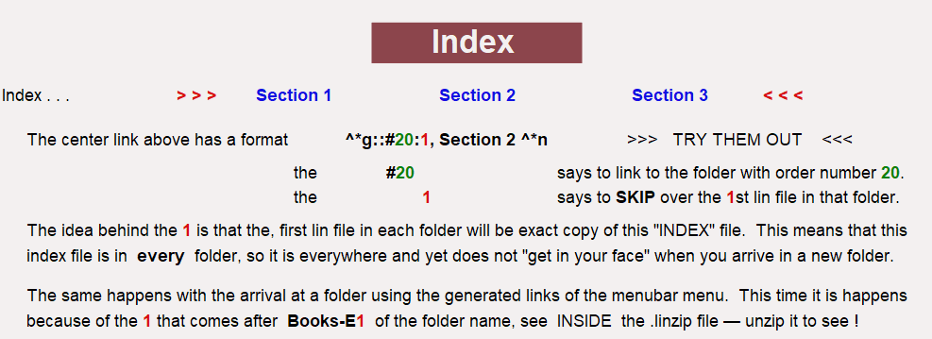
The assumption is that the same index file will be put into every folder (section) of your linzip file.
The feature, described in the image above, will then allow users to jump from section to section and yet only see the index when they want it, as it will always be the first file in each folder.
<end of document>

